**CHAPTER 1**

**INTRODUCTION:**

Present project is designed using microcontroller to avoid railway accidents happening at unattended railway gates, if implemented in spirit. This project utilizes two powerful IR transmitters and two receivers; one pair of transmitter and receiver is fixed at up side (from where the train comes) at a level higher than a human being in exact alignment and similarly the other pair is fixed at down side of the train direction. We have considered 5 seconds for this project. Sensors are fixed at 2km on both sides of the gate. When foreside receiver gets activated, the gate motor is turned on in one direction and the gate is closed and stays closed until the train crosses the gate and reaches aft side sensors. When aft side receiver gets activated motor turns in opposite direction and gate opens and motor stops. Buzzer will immediately sound at the fore side receiver activation and gate will close after 5 seconds, so giving time to drivers to clear gate area in order to avoid trapping between the gates and stop sound after the train has crossed.

The same principle is applied for track switching. Considering a situation wherein an express train and a local train are traveling in opposite directions on the same track, the express train is allowed to travel on the same track and the local train has to switch on to the other track. Two sensors are placed at the either sides of the junction where the track switches. If there’s a train approaching from the other side, then another sensor placed along that direction gets activated and will send an interrupt to the controller. The interrupt service routine switches the track. Indicator lights have been provided to avoid collisions. Here the switching operation is performed using a stepper motor. Assuming that within a certain delay, the train has passed the track is switched back to its original position, allowing the first train to pass without any interruption. This concept of track switching can be applied at 1km distance from the stations. This project diagnoses the condition of crossing gates, detects any trapped obstacles, and tracks the movement of obstacles in real time. This subsystem installed in the cabin of the train, warning message is sent to this and the train operator will take the necessary actions. In case if he fail to notice this we are employing the automatic braking system which will take care of the slowdown of train. As we are including the obstacle detection in this project we can alert the train in this regard. Further this project can be implemented in tunnels and hill stations in order prevent accident of wildlife. With this we can save the life of wildlife like ELEPHANT.

**CHAPTER 2**

**LITERATURE SURVEY:**

PAPER 1

Development of a Smart Railway System for Bangladesh. This paper suggests an approach towards an intelligent and automatic management of a railway transportation system in order to prevent hazards like collisions and derailments. The system is designed as such that it is most viable for Bangladesh, however, it can also be easily implemented at any other railway infrastructure. The system features active train detection using global navigation satellite system (GNSS) coordinates and obstacle detection at level crossings using long range infrared; automatic signalling and gate control at level crossings using light emitting diodes (LEDs) and servo motors; automatic and manual communication between trains and level crossings using global system for mobile communicate on (GSM) technology and lastly development of a web-based central control system to monitor locations and activities of trains using navigation technology and to communicate with the entire railway community as well as the country’s emergency services. Our design includes the integration and interaction of three separate sub-systems: central control system, level crossing system and train system. Implementation of such a system in Bangladesh Railway will not only provide a comprehensive level of safety in railway transportation but also take Bangladesh a step forward towards the much-anticipated dream by Bangladesh government of creating a ‘Digital Bangladesh’.

Trains and level crossings communicate by SMS messages. The core features of the entire system are:

1. Train-to-train collision detections
2. Excessive train speeds detection and response
3. Live view of all trains on-route of the country in a Google Map API in the central control system.
4. Communicate and command trains through the central control system.
5. Detect approaching trains at level crossings and open or close level crossing gates automatically.
6. Detect obstacles at different positions of the level crossing and warn the approaching train about it.

PAPER 2:

Evaluation of Communication Channel for Train Safety Monitoring System

In this paper, we will introduce the necessity of real-time safety monitoring system for high-speed railway vehicle and propose a new type of safety monitoring system using a low-power wireless connection. To verify the proposed safety monitoring system is feasible, we measure the packet error rate on the moving train and show the analysed results. In railway vehicles such as high-speed trains or freight trains, safety monitoring is very important to prevent passengers and freight from an accident like a derailment. And the demand of safety monitoring is being increased. Safety monitoring system usually consists of safety monitoring service module and sensor module. Safety monitoring service module analyses the key parameters which sensor module collects and make a decision on the safety status of moving a train. Sensor module acquires key parameter values such as the temperature of wheel and bearing or the vibration acceleration of wheel axles. Those values are directly related to the safety of the railway vehicles by using a physical sensor. In this paper, we will divide the methods of safety monitoring system into real-time measurement and non-real time measurement according to the collection interval of key parameters. In the case of real-time measurement, to exactly detect the abnormal state of a train, a large amount of sensor data is needed. In the case of vibration acceleration data, the sampling interval can be reached up to 4-5KHz. Monitoring service module and sensor module are typically connected by wire for stable and broadband data communication. And safety monitoring system is installed on the vehicle. In the case of a freight train, the power line does not reach to the underbody of the vehicle. So applying safety monitoring system to freight train is difficult. And the coverage of safety monitoring system might be very limited. Uneasiness of installation and power supply to the underbody of vehicles are the main disadvantages of real-time measurement method. Monitoring system using HBD is the representative way of non-real-time measurement. It is installed on the railroad, not on the train. So, the key parameters are measured only when train passes HBD. It is provided with tens of kms interval along the railroad

In this type of system, wired connection between monitoring service module and sensor module is replaced by a wireless connection. And if energy harvest module is used as the power source of a sensor module, safety monitoring system is used for a freight train. A large amount of vibration is generated during the moving of train. Harvest module uses vibration to generate power for communication module. We think the wireless communication module based on energy harvest will be a good solution for real-time safety monitoring system for various railway vehicles. In wireless safety monitoring system, The quality of communication channel between outside and inside of train is very important, because sensor data acquired from outside sensor module should be delivered to inside safety monitoring service module without a loss while keeping a certain transmission rate. In this paper, we primarily focus on the quality of wireless channel and communication module.

PAPER 3:

Unmanned Level Crossing Controller and Rail Track Broken Detection System Using IR Sensors and Internet of Things Technology

Railways provide the cheapest and most convenient mode of passenger transport both for long distance and suburban traffic. Also, most of transport in India is being carried out by railway network. Still accidents are the major concern in terms of railway track crossing and unidentified crack in rail tracks in Indian railway. About 60% accidents are occurring at railway track crossing and due to crack in railway tracks resulting in loss of precious life and loss of economy. Therefore there is need to think about new technology which is robust, efficient and stable for both automatic gate closure system and crack detection in railway track. This paper proposes an unmanned gate crossing and faulty rail track detection. Unmanned level crossing is a IR sensors base system and crack detection is an dynamic approach which combines the use of GPS (global positioning system) tracking system and GSM (global system for mobile communication) modem to send geographical coordinate of location. Unmanned gate crossing controller system prevents accident which are caused due to railway track crossing and railway crack detection system prevents train derailment by detecting crack in railway track using internet of things technology.

In this proposed system we used LPC2148 Microcontroller. It is a 64 pin High Performance ARM microcontroller. It is also tiny size and low power consumption microcontroller. Due to their tiny size and low power consumption, LPC2148 are ideal for application where miniaturization is a key requirement ,such as access control system. It has serial communication interfaces ranging from a USB 2.0 Full Speed device , multiple UARTS,SPI,SSP to I2Cs.It has on-chip SRAM of 8 kb up to 40kb. This makes devices very well suited for communication gateway .In this paper we have proposed two systems.

PAPER 4

Automatic Rail Fault Track Detection for Indian Railways

Indian railway is the largest railway network in Asia and additionally world’s second largest network operated underneath a single management. The railways became the prime suggests that of transportation because of their capability, speed and responsibleness. Even a small improvement in this sector will aid the overall development of a nation. Due to the gigantic size, it's a tedious task to monitor and maintain the rails in a timely manner. The poor maintenance of the railway tracks will result in accidents. Occurrence of cracks in tracks became a serious concern for the railway. The rail cracks should be identified and corrected as early as possible as it poses a serious threat to the safe operation of the carriages. This proposal aims at elimination of the long prevailing issues in this sector. This effective methodology of continuous observation and assessment of rail tracks might facilitate to stop accidents. This methodology endlessly monitors the rail stress, evaluate the results and provide the rail break alerts such as potential buckling conditions, bending of rails and wheel impact load detection to the concerned authorities.

The proposed system consists of a gauge which finds the amount of stress that is being applied over the rail lines during the train passes through it. The stress on the wheels and rails are the primary indicators. Strainguages are employed for measuring the above said factors. Knowing the dynamic parameters of the rail (Young’s modulus E, Poisson’s ratio ν) and its geometrical characteristics (web thickness t, geometrical moment of inertia I, ﬁrst moment of space H) the theoretical value of the strain can be calculated for a particular stress. By comparing the experimental values and the theoretically calculated values the possibilities of a rail fault can be easily find out. The amount of strain developed on a traditional track and a broken track will be completely different. The use of accelerometer device on the track might facilitate to seek out if there's any abnormal bending is caused once a train passes over through the track. Also ultrasonic sensors are used along with this module, which are placed on both sides of the tracks. If any changes in the width or length of the tracks ,these sensors detects it and alert the operator. The temperature sensors are used sense the track temperatures. The sharp changes in temperature are a reason for buckling. The outputs of those sensors are coordinated and transmitted to the closest station. When a higher degree deviation from the conventional value occurs the alerting system within the station master’s space might get activated and corrective measures can be taken in a timely manner. The power requirement for the proposed system is very less and it can be even powered with the assistance of solar cells or by the employment of piezoelectric energy generation methodology.

**CHAPTER 3**

**PROBLEM STATEMENT:**

Today often we see newspapers very often about the railway accidents happening at un- attended railway gates. Present project is designed to avoid such accidents if implemented in spirit. The same principle is applied for track switching without human intervention. Considering a situation wherein an express train and a local train are traveling in opposite directions on the same track; the express train is allowed to travel on the same track and the local train has to switch on to the other track in order to avoid accidents. While in case if a vehicle is stuck in between the gates due to some reasons, there might be a chances of accidents too. As we are including the obstacle detection in this project we can alert the train in this regard. Further this project can be implemented in tunnels and hill stations in order prevent accident of wildlife. With this we can save the life of wildlife like ELEPHANT. As when they are going in a group sometimes there is a chance of getting hit by train. We as a engineers need to do something to help them and save their life.

**CHAPTER 4**

**OBJECTIVE:**

Aim of this project is control the unmanned rail gate automatically using embedded platform. Present project is designed to avoid such accidents if implemented in spirit. This project utilizes two powerful IR transmitter and two receivers, one pair of transmitter and receiver is fixed at upside (from the train comes) at a level higher than human being in exact alignment and similarly other pair is fixed at down side of the train direction sensor activation time is so adjusted by calculating the time taken at a certain speed to cross at least one compartment of standard minimum size of the Indian railway, normally 5 seconds. The sensors are fixed at 5000 meters on both sides of the gate, we call fore side sensor pair for common towards gate train, and aft side sensors for the train just Crosses the gate. When train cross the fore side sensor it gives signal to the gate receiver to close the gate. The buzzer is activated to clear the gate area for drivers about 5-10 seconds. Gate motor is turned on in one direction and gate is closed, and stay closed till train crosses the gate and reaches aft side sensors when aft side receiver get activated motor turns in opposite direction and gate opens and motor stops . If there is any problem in the gate means it will operate red signal on both side for the driver indication. Train arrival and departure sensing can be achieved by means of Relay techniques. When the wheels of the train moves over, both tracks are shorted to ground and this acts as a signal to microcontroller indicating train arrival. RED signal appears for the road user, once the train cuts the relay sensor placed before the 5Kms before the gate. A buzzer is made on as a pre cautionary measure for the road users.

Using the same principle as that for gate control, we have developed a concept of automatic track switching. Considering a situation wherein an express train and a local train are traveling in opposite directions on the same track.

We are going to implement this project in hilly region and inside the tunnels. By doing so we are going to make sure that no animal is get hit by trains.

**CHAPTER 5**

**methodology:**

**Block diagram :-**

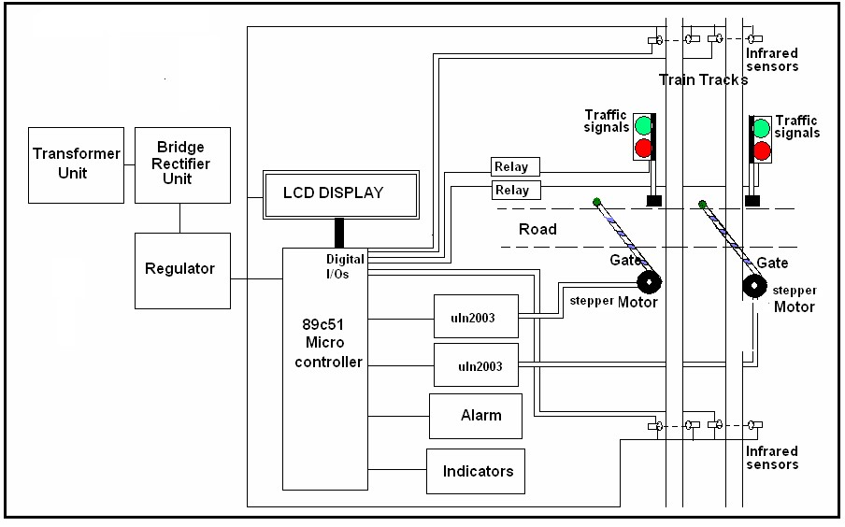

**FIG 2.1.**

The above figureshows the general block diagram of unmanned railway gate control, the various blocks of this are:

1. Power supply unit

1. Gate control unit
2. Track changing unit
3. LCD Message display unit

This project uses microcontroller like Arduino or raspberry pi for programming and operation.

The supply from 7805 regulator is used for the purpose of track changing which consists of a stepper motor driven with ULN2003 the current driver chip. The supply of 12v is given to drive the stepper motor for the purpose of gate control. Through uln2003

**2.2 Operation:**

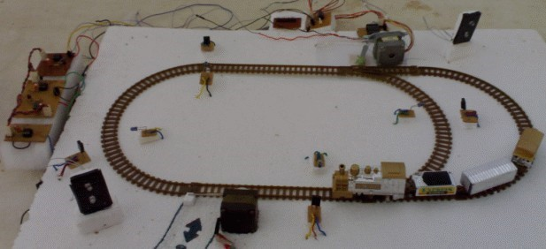

**Fig 2.2.** shows the of view of model project**.**

This project utilizes two powerful IR transmitters and two receivers; one pair of transmitter and receiver is fixed at up side (from where the train comes) at a level higher than a human being in exact alignment and similarly the other pair is fixed at down side of the train direction. Sensor activation time is so adjusted by calculating the time taken at a certain speed to cross at least one compartment of standard minimum size of the Indian railway. We have considered 5 seconds for this project. Sensors are fixed at 1km on both sides of the gate. We call the sensor along the train direction as ‘foreside sensor’ and the other as ‘aft side sensor’. When foreside receiver gets activated, the gate motor is turned on in one direction and the gate is closed and stays closed until the train crosses the gate and reaches aft side sensors. When aft side receiver gets activated motor turns in opposite direction and gate opens and motor stops. Buzzer will immediately sound at the fore side receiver activation and gate will close after 5 seconds, so giving time to drivers to clear gate area in order to avoid trapping between the gates and stop sound after the train has crossed.

The same principle is applied for track switching. Considering a situation wherein an express train and a local train are traveling in opposite directions on the same track; the express train is allowed to travel on the same track and the local train has to switch on to the other track. Two sensors are placed at the either sides of the junction where the track switches. If there’s a train approaching from the other side, then another sensor placed along that direction gets activated and will send an interrupt to the controller. The interrupt service routine switches the track. Indicator lights have been provided to avoid collisions. Here the switching operation is performed using a stepper motor. Assuming that within a certain delay, the train has passed the track is switched back to its original position, allowing the first train to pass without any interruption. This concept of track switching can be applied at 1km distance from the stations.

In this project Micro controller Integrated Chip plays the main role. The program for this project is embedded in this Micro controller Integrated Chip and interfaced to all the peripherals. The timer program is inside the Micro controller IC to maintain all the functions as per the scheduled time. The Liquid crystal Display (LCD) is interfaced to Micro controller to display the message, stepper motors are used for the purpose of gate control and track changing interfaced with current drivers chip ULN2003 it’s a 16 pin IC.

Infrared sensors are used in this for the detection of the train when ever it sends a signal to microcontroller the stepper motor should operate or message will be displayed on LCD. It consists of units called transmitter and receiver circuit.

Infrared sensor circuit consists of IC555 timer C 555 is used to construct an astable multivibrator which has two quasi-stable states. It generates a square wave of frequency 38 kHz and amplitude 5Volts. It is required to switch ‘ON’ the IR LED.

A stepper motor is a widely used device that translates electrical pulses into mechanical movement. They function as their name suggests - they “step” a little bit at a time.

The software is written in C-language and is dumped to the microcontroller to run the project.

Operation of this project can be explained through three units:

1. Gate control unit
2. Track changing unit
3. Announcement unit
4. Two trains opposite on same track case

**2.2.1 Gate control unit:**

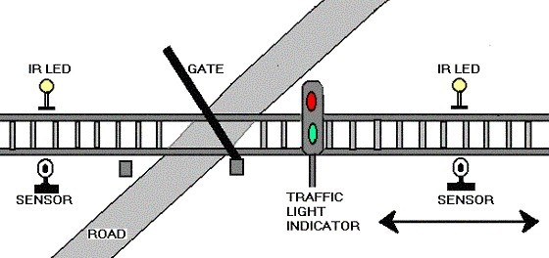

# **FIG: 2.2.1**

Railways being the cheapest mode of transportation are preferred over all the other means .When we go through the daily newspapers we come across many railway accidents occurring at unmanned railway crossings. This is mainly due to the carelessness in manual operations or lack of workers. We, in this project have come up with a solution for the same. Using simple electronic components we have tried to automate the control of railway gates. As a train approaches the railway crossing from either side, the sensors placed at a certain distance from the gate detects the approaching train and accordingly controls the operation of the gate. Also an indicator light has been provided to alert the motorists about the approaching train.

The above figure shows the gate controlling unit block diagram. Its operation can be explained through that.

As the figure shows it consists of two pairs of infrared sensors placed at two sides of gate. They should keep at a distance of 9 cm (2km in usual case) from the gate. and a stepper motor is used for the purpose of the gate closing and opening. Interfaced to the ULN2003.

When train reaches the sensor, it is detected by IR sensors placed 9 cm before the station and led in the sensor will glow because the 555 timer works into quasi state of operation. such that the IR LED should glow till the timer works in quasi state i.e., when train passes away the sensors it again into normal state then it receives 5v at terminals that pin at the 89c51 terminal goes high which enables the power to the stepper motor to rotate in steps which drives gate to close similarly when it reaches the second pair of sensors it senses and send the signal to the microcontroller to enable the current driver to open the gate by rotating the stepper motor in steps to get back in to original position.

**2.2.2 Track changing unit:**

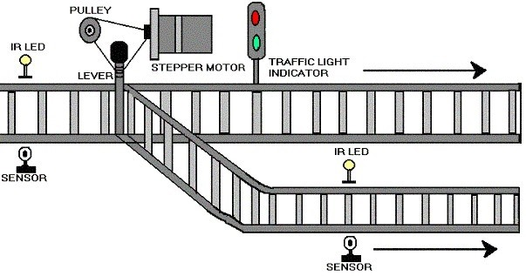

**FIG: 2.2.2**

Using the same principle as that for gate control, we have developed a concept of automatic track switching. Considering a situation wherein an express train and a local train are traveling in opposite directions on the same track; the express train is allowed to travel on the same track and the local train has to switch on to the other track. Indicator lights have been provided to avoid collisions .Here the switching operation is performed using a stepper motor. In practical purposes this can be achieved using electromagnets.

When train reaches the platform before a 10cm distance apart a set of sensors are placed to detect the train and two pair of sensors are placed on each of track at platforms. When the train is at the first pair of sensors it sends a signal to microcontroller to know the availability of plat form. Here after checking availability microcontroller operates stepper motor to change the track. The mechanism is arranged as shown in fig. but in this case the track changing is done due to second sensor that used to open the gate. It consists of 5v driven stepper motor, ULN 2003 current driver chip and pulley for track changing mechanism.

**2.2.3 Announcement unit:**

Usually, announcement made at the station for the information of train arrival and departure. In this model we are using a buzzer for the announcement and LCD for the purpose of display message. LCD is interfaced to 89C51 microcontroller.

The announcement and display message is according to the second sensor which should be used for the purpose of gate opening.

**2.2.3.1 Train arrival detection**:

Detection of train approaching the gate can be sensed by means of sensors R1, R2, R3&R4 placed on either side of the gate. In particular direction of approach, R1 is used to sense the arrival; R3 is used to sense the departure of the train. In the same way R4&R2 senses arrival and departure in the other direction. Train arrival and departure sensing can be achieved by means of relay technique. A confined part of parallel track is supplied with positive voltage and ground. As wheels of the train, is made up of aluminium which is a conducting material, it shorts two parallel tracks. When the wheels of the train moves over it, both tracks are shorted to ground and this acts as a signal to microcontroller indicating train arrival. The train detection in the other direction is done in the same way by the sensors R1 & R4. These sensors are placed five kilometres before the gate**.**

**2.2.3.2 warning for road users:**

At that moment the train arrival is sensed on either of the gate, road users are warned about the train approach by RED signal placed to caution the road users passing through the gate .RED signal appears for the road user, once the train cuts the relay sensor placed before the 5Kms before the gate .A buzzer is for train, when there is any obstacle; signal is made RED for train in order to slow done its speed before 5km from gate.

**2.2.3.3 Train departure detection:**

Detection of train is also done using relay techniques as explained the head of train arrival detection. Sensor R3&R2 respectively considering direction of train approach do train departure.

A message is displayed on LCD when train reaches the platform. Sensed by IR sensors.

**Future enhancement**:

In our technique though it has many merits, but still the power supply of 223V AC POWER is required for functioning of the motor. It can be avoided with the help of a battery charged by a Solar Cell. Since solar energy is an inexhaustible natural source of energy.

**2.2.4 Two trains opposite on same track:**

We know that the rate of accidents increasing day by day, in this because failure of mechanism at track changing two trains coming on same track. This can also happens some times due to human negligence. This can avoided by using the following unmanned detection for two trains coming on same track case.

In our model of project, we are using the gate controlling pair of sensors to execute this method. i.e., when two trains are coming same track at that location the two sensors will operate at a time i.e., two 555 timers of circuit are driven in to quasi stable state and thus corresponding two buzzer will operate at a time and two IR LED will operate and hence signal sends to micro processor to operate the stepper motor at tack changing.

The components that we use in order to execute are stepper motor 5v, ULN2003, AT89C51 AND IR sensors.

**2.2.5 Initial signal display:**

Signals are placed near gate each at a specified distance. Train may be approaching gate at either direction so all four signals are made RED initially to indicate gate is OPENED and vehicles are going through gate. The road user signals are made GREEN so that they freely move through gate. Buzzer is OFF since there is no approach of train and users need not be warned.

**CHAPTER 6**

**HARDWARE REQUIREMENTS**:

1. MICRO CONTROLLER
2. IR SENSOR
3. STEPPER MOTOR
4. LCD DISPLAY
5. BUZZER AND LED
6. ACCELEROMETER.
7. PCB BOARDS.

**SOFTWARE REQUIREMENTS**:

1. ARDUINO IDE
2. PROCESSING IDE